1. Install Matplotlib and display a simple line graph
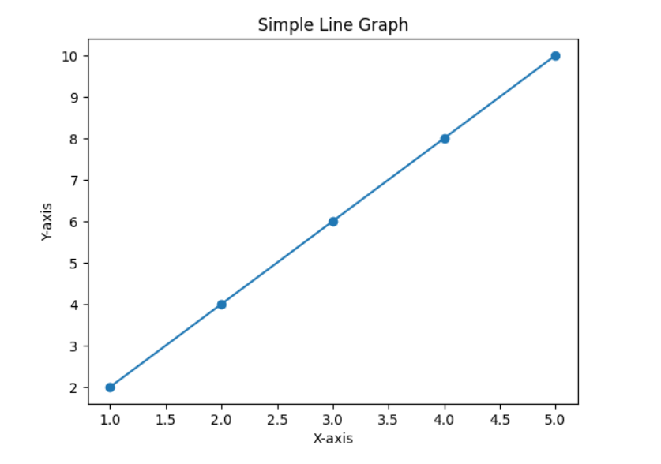
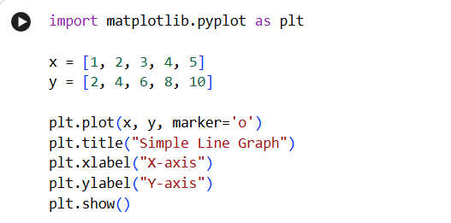

2. Install Scikit-learn and print its version
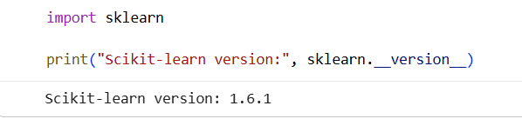
3. Create a NumPy array containing the first 20 natural numbers
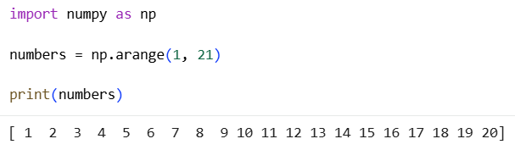

4. Create a Pandas DataFrame with student names and grades
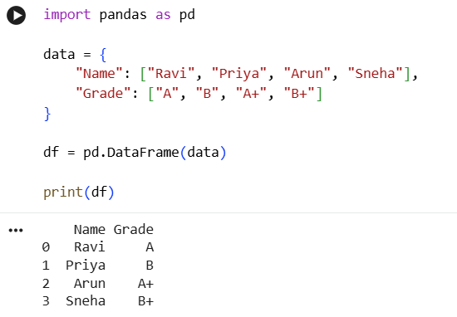
5. Verify the installed versions of all AI libraries on your system
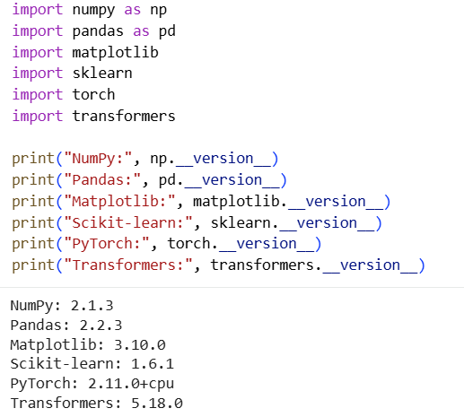

6. Create tensors using PyTorch and perform basic mathematical operations
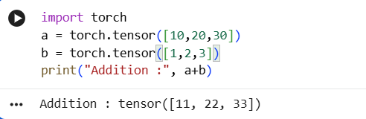
7. Load a pre-trained Transformer model using Hugging Face and perform sentiment analysis
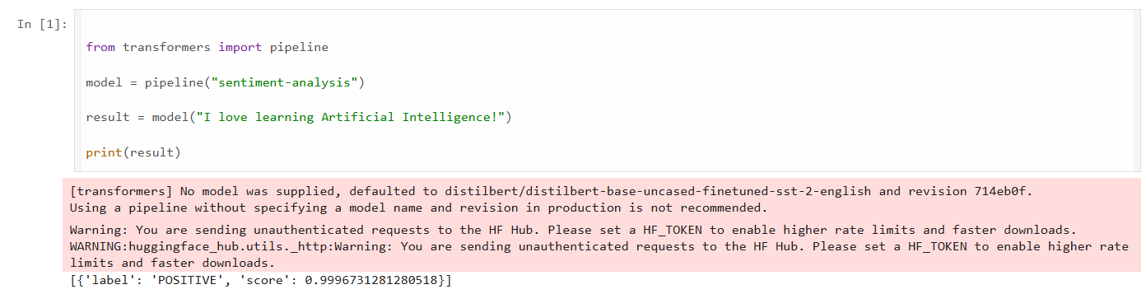
8. Tokenization using BERT Tokenizer
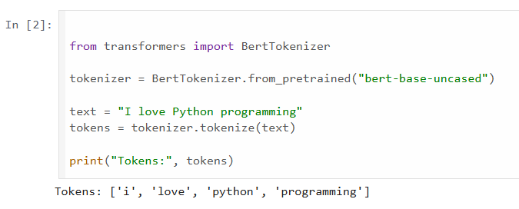
9. Generate text using a pre-trained GPT-2 model
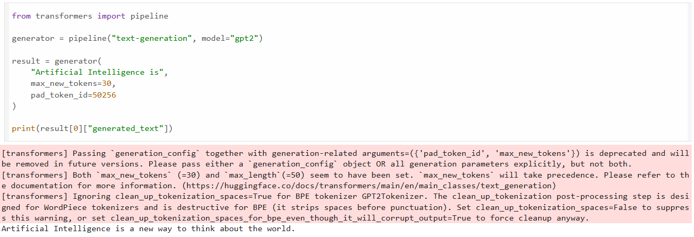

10. Load a pre-trained Transformer model using the Hugging Face pipeline() API and perform sentiment analysis
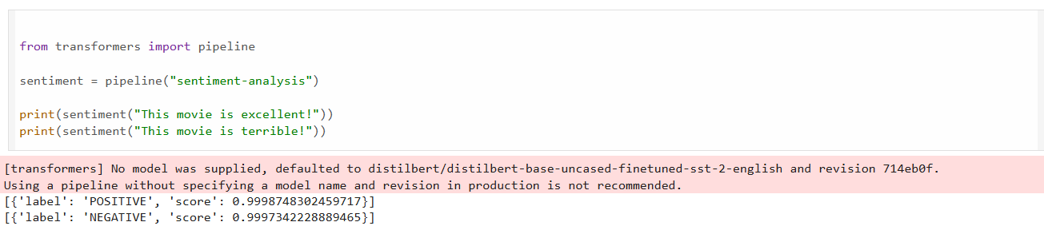
11. Load the BERT tokenizer and tokenize a sentence
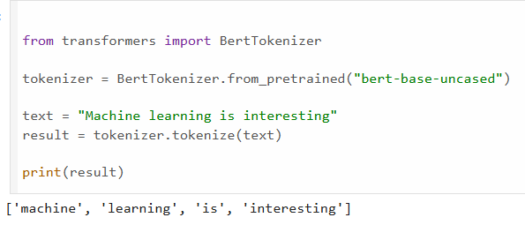
12. Load a pre-trained BERT model and generate contextual embeddings
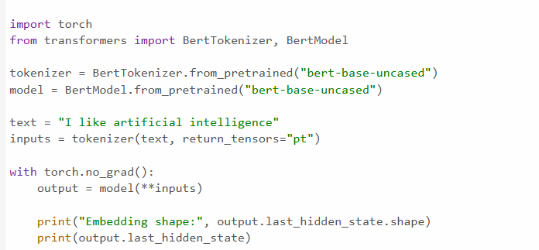

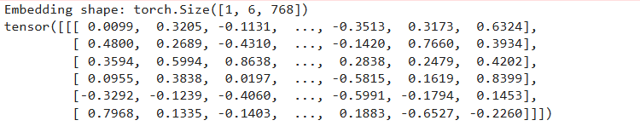

13. Generate text using a pre-trained GPT-2 model

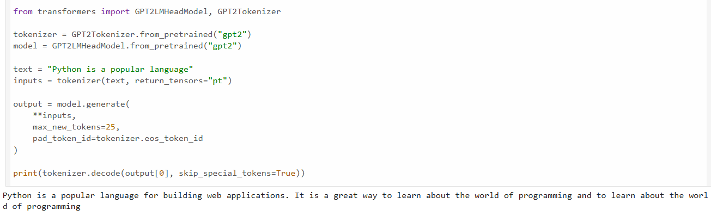
14. Question Answering using a pre-trained Transformer
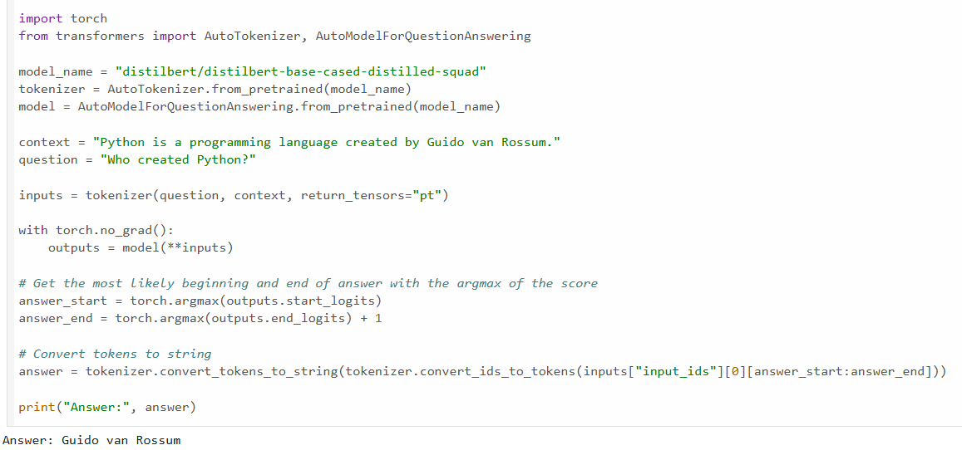
15. Tokenize a sentence using BERT and display the generated tokens and token IDs
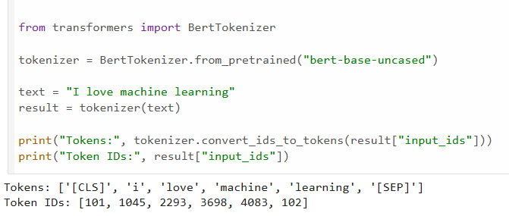

16. Compare the tokenization outputs of BERT and GPT-2
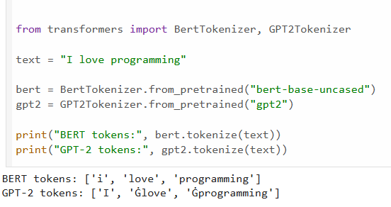
17. Generate contextual embeddings for a sentence using BERT
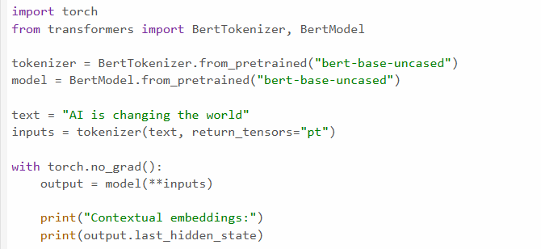
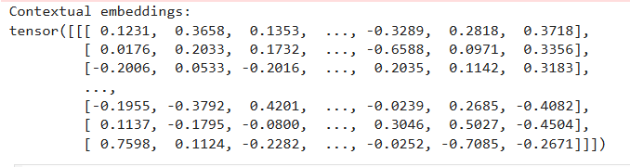
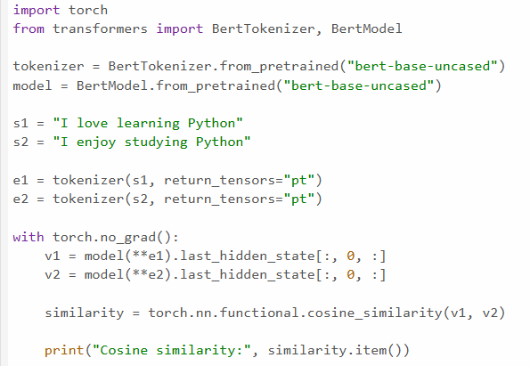
18. Compare contextual embeddings generated for two semantically similar sentences

19. Generate text from a prompt using the GPT-2 language model
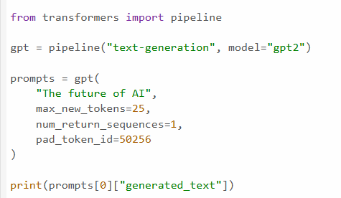

20. Generate and compare responses for multiple prompts using a pre-trained LLM
